**BUILDING A DATABASE FROM SCRATCH**

**DOMAIN EXPERTISE - SPORT(FITNESS)**



Title: “**PEAKPACER”**: A Fitness Tracking Application"

Subtitle: "Empowering Individuals Towards Fitness Excellence: A Holistic Approach to Health and Wellness"

INTRODUCTION:

Brief overview of the **PEAKPACER** application

**PEAKPACER** is a cutting-edge fitness tracking application designed to empower users on their health and wellness journey. It offers a comprehensive suite of features, including real-time activity tracking, personalized goal setting, and progress monitoring. With an intuitive user interface, **PEAKPACER** seamlessly integrates data from various fitness metrics, providing users with actionable insights to enhance their fitness routines. From step counts to calorie burn, **PEAKPACER** is dedicated to facilitating a holistic and personalized health monitoring experience, encouraging individuals to achieve their fitness goals with precision and motivation..

THE GOALS AND PURPOSE

The " **PEAKPACER**" Fitness Tracking App is designed with specific goals and purposes to cater to the needs of users striving for a healthier and more active lifestyle. The key objectives include:

1. Empowering Goal Achievement:

**PEAKPACER**" encourages users to define and pursue personalized fitness goals. Whether it's running longer distances, increasing weight lifting capacity, or achieving specific health milestones, the app motivates users to set and attain their unique objectives.

1. Insightful Performance Feedback:

The app provides valuable insights and feedback on users' performance, offering detailed analyses of fitness metrics. Users can access comprehensive data on their progress, identify areas for improvement, and receive tailored recommendations to optimize their workouts.

1. Progress Monitoring and Results Visualization:

" **PEAKPACER**" allows users to visually track their fitness journey over time. By monitoring changes in fitness levels and visualizing tangible results, users gain a clear understanding of the impact of their efforts, fostering motivation and commitment.

1. Accountability and Consistency:

**PEAKPACER** promotes accountability by enabling users to track their daily physical activity and exercise habits. Through consistent monitoring, users can adhere to their fitness routines, stay on course with their goals, and make informed adjustments as needed.

5. Comprehensive Health and Wellness Support:

Beyond exercise tracking, "**PEAKPACER**" emphasizes overall health and wellness. It serves as a holistic health companion, encouraging users to adopt healthy habits, manage stress, and strike a balance between physical activity and other aspects of their lives.

The ultimate aim of the "**PEAKPACER**" Fitness Tracking App is to empower users to take charge of their well-being, celebrate their achievements, and embark on a fulfilling journey toward a healthier and more active lifestyle. By providing personalized support and insights, the app becomes a trusted companion in each user's unique fitness adventure.

# THE NEED FOR THE FITNESS TRACKING APPLICATION " PEAKPACER”

**PEAKPACER** is a cutting-edge fitness tracking application designed to empower users on their health and wellness journey. It offers a comprehensive suite of features, including real-time activity tracking, personalized goal setting, and progress monitoring.

With an intuitive user interface, **PEAKPACER** seamlessly integrates data from various fitness metrics, providing users with actionable insights to enhance their fitness routines.

From step counts to calorie burn, **PEAKPACER** is dedicated to facilitating a holistic and personalized health monitoring experience, encouraging individuals to achieve their fitness goals with precision and motivation.

The need for **PEAKPACER** arises from the growing demand for a streamlined and personalized approach to health and fitness monitoring. In today's fast-paced lifestyle, individuals face challenges in maintaining a healthy balance. **PEAKPACER** addresses this need by offering a convenient and centralized platform for users to track their physical activities, set achievable fitness goals, and monitor their progress over time.

With sedentary lifestyles becoming more prevalent, there is a heightened awareness of the importance of regular exercise and overall well-being. **PEAKPACER**  responds to this need by providing a solution that not only tracks activities but also encourages users to adopt healthier habits. Whether it's tracking steps, monitoring heart rate, or analyzing sleep patterns, **PEAKPACER**  aims to be a companion that motivates users to make informed decisions about their health.

The need for **PEAKPACER** is further underscored by the desire for data-driven insights into one's fitness journey. People seek a tool that goes beyond basic tracking, offering meaningful interpretations of their activities and suggesting improvements tailored to individual preferences and health objectives. Overall, **PEAKPACER** emerges as an essential fitness tracking application to address the contemporary need for accessible, personalized, and effective health monitoring.

# CHALLENGES IN MONITORING THE HEALTH AND FITNESS GOALS

In the present world, individuals encounter several challenges when it comes to monitoring their health and fitness goals.These are the challenges that **PEAKPACER** is poised to address and prevent:

1. Lack of Time and Busy Lifestyles:

- Challenge: Modern lifestyles often involve demanding schedules, leaving individuals with limited time for dedicated fitness activities.

- Solution: **PEAKPACER** provides quick and efficient ways to track activities, accommodating busy schedules and encouraging users to integrate fitness into their daily routines.

2. Information Overload:

- Challenge: The abundance of health and fitness information can be overwhelming, making it difficult for users to discern relevant insights for their specific goals.

- Solution: **PEAKPACER** simplifies data interpretation, offering personalized recommendations based on individual metrics to help users focus on key aspects of their health.

3. Lack of Motivation and Accountability:

- Challenge: Staying motivated is a common hurdle, and without a support system, individuals may struggle to adhere to their fitness plans.

- Solution: **PEAKPACER** incorporates motivational features, such as goal-setting and progress tracking, to keep users engaged and accountable on their fitness journeys.

4. Inconsistent Tracking:

- Challenge: Users may find it challenging to consistently track their activities and monitor progress over time.

- Solution: **PEAKPACER**  provides real-time tracking and automated logging, which ensures that users have a seamless experience in keeping tabs on their fitness activities without manual effort.

5. Lack of Personalization:

- Challenge: Generic fitness plans may not cater to individual preferences, making it difficult for users to adhere to their routines.

- Solution: **PEAKPACER** tailors recommendations based on users' unique profiles, preferences, and goals, ensuring a personalized and sustainable approach to health and fitness.

6. Difficulty in Setting Realistic Goals:

- Challenge: Users may struggle to set achievable fitness goals, leading to frustration and disengagement.

- Solution: **PEAKPACER** assists users in setting realistic and personalized goals, guiding them towards milestones that align with their fitness levels and aspirations.

By addressing these challenges, **PEAKPACER**  aims to create a user-friendly and supportive environment, empowering individuals to overcome obstacles and achieve lasting success in their health and fitness endeavors.

# CODE INTERPRETATIONS

The interpretation of the codes for **PEAKPACER** have being written with the codes on MySQL script submitted. And it includes snippets of code for the creation the application “**PEAKPACER”** and its interpretation. It interprets the code to explain its functionality and significance with the execution.

DATABASE STRUCTURE

Using Draw.io, the Database schema was created and used to run codes on the MySQL and Postgres SQL showing how the tables were created and related .

THE DATABASE SCHEMA USED IN MYSQL FOR PEAKPACER.

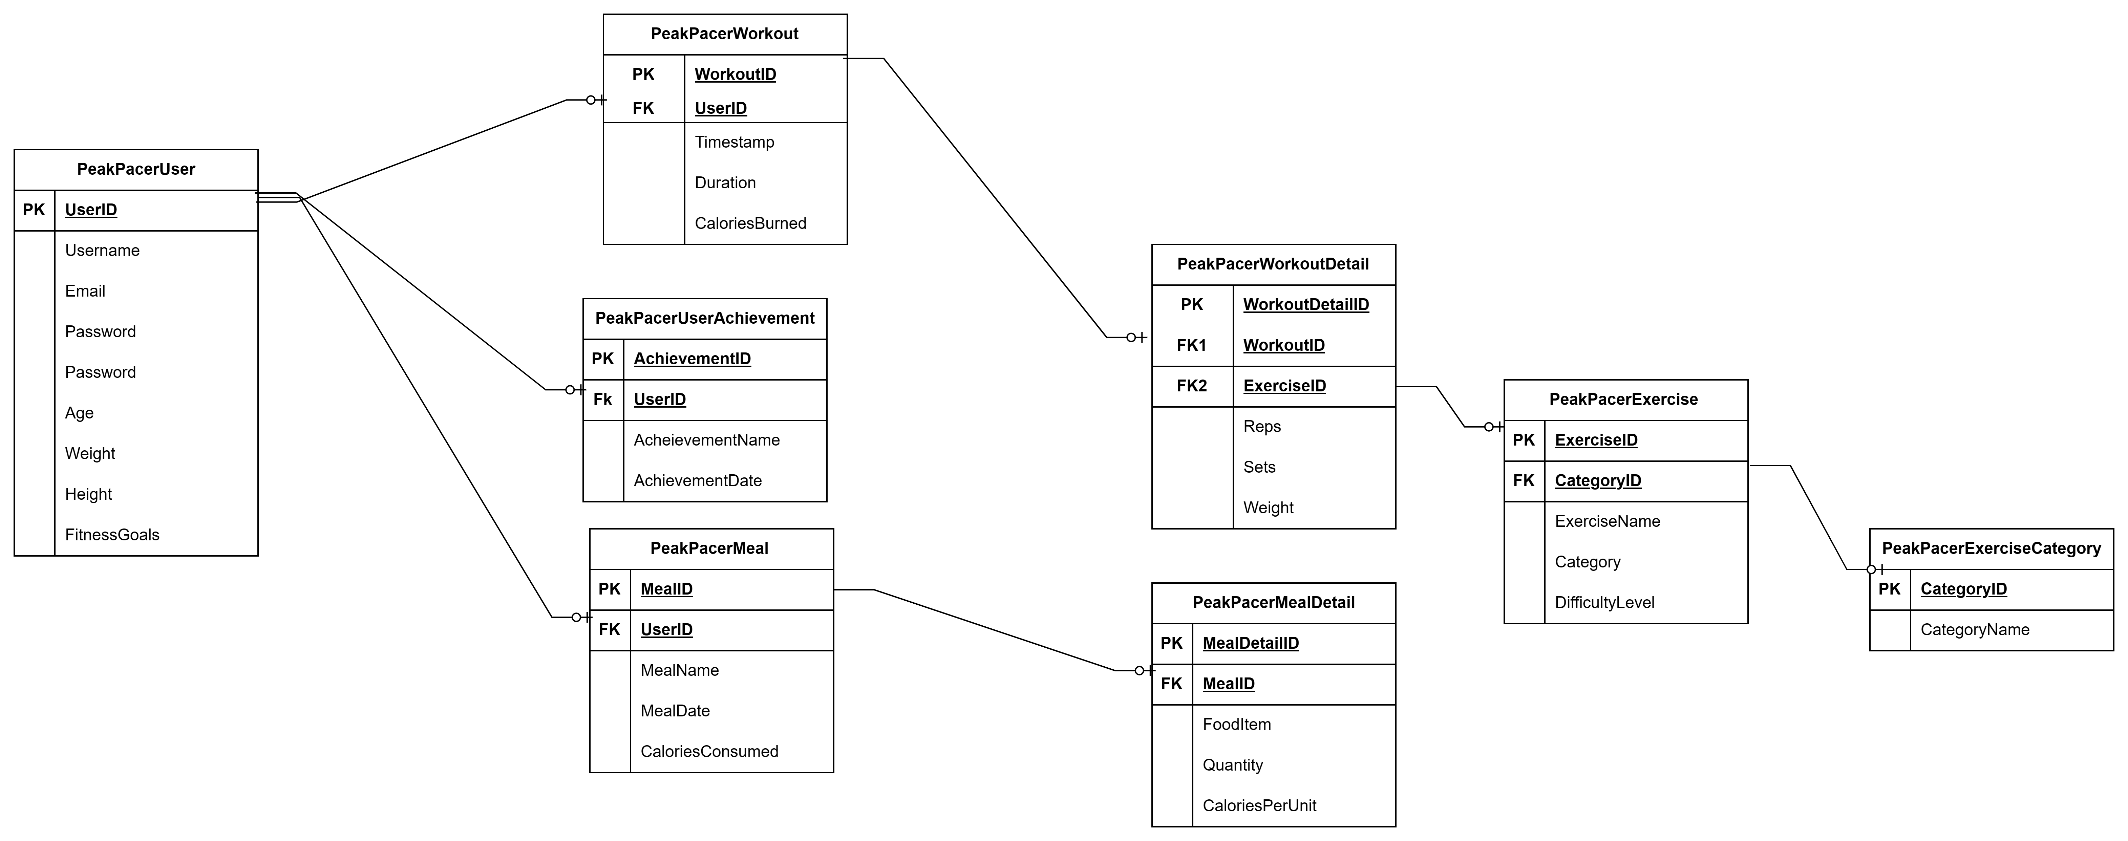

# QUERY INTERPRETATIONS

10 sample SQL queries was required to be created. The following queries was used in the application;

* Query to retrieve users

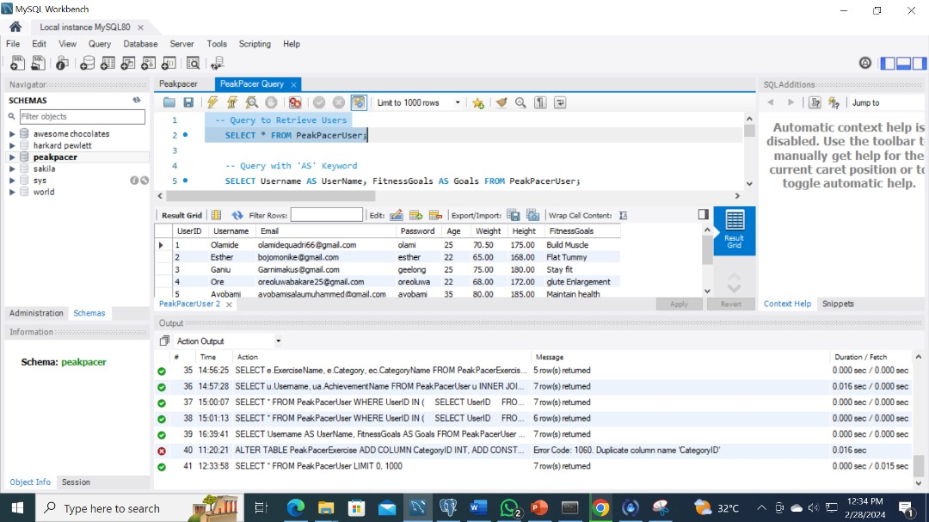

* Query with ‘AS’ keyword
* Query with ‘OR’ keyword

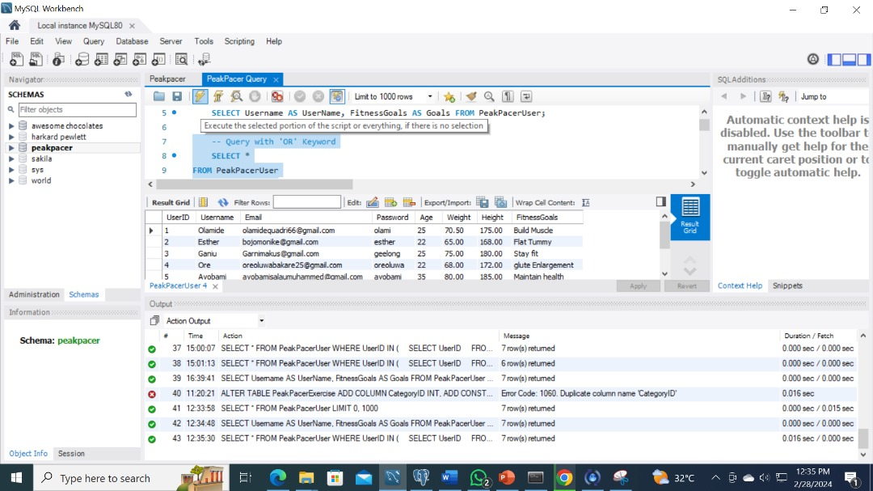

* Query with ‘AND’ keyword

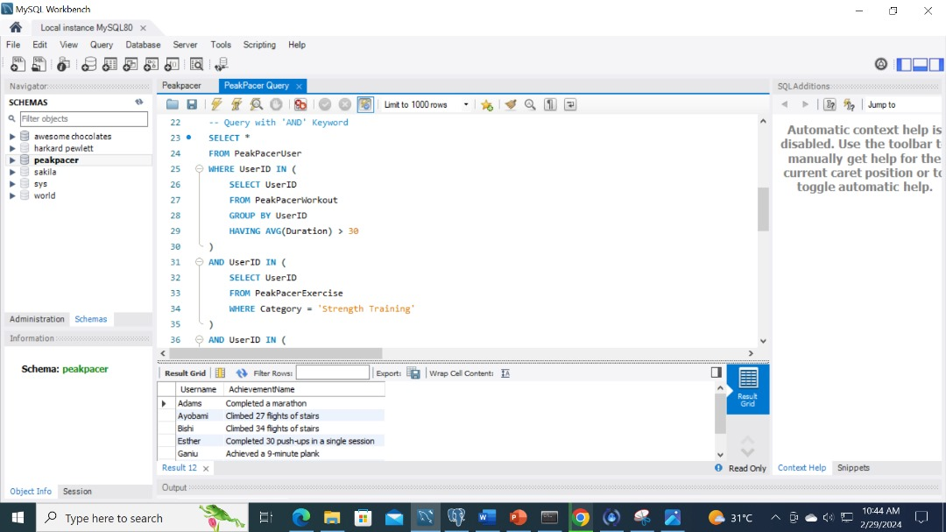

* Query with ‘GROUP BY’ keyword

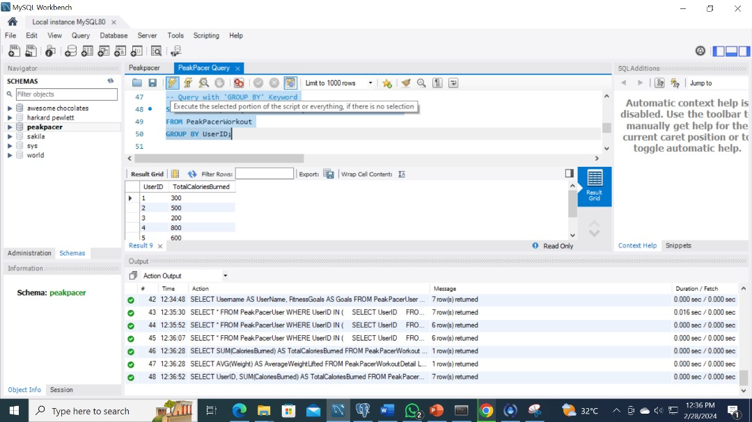

* Query with ‘HAVING’ keyword

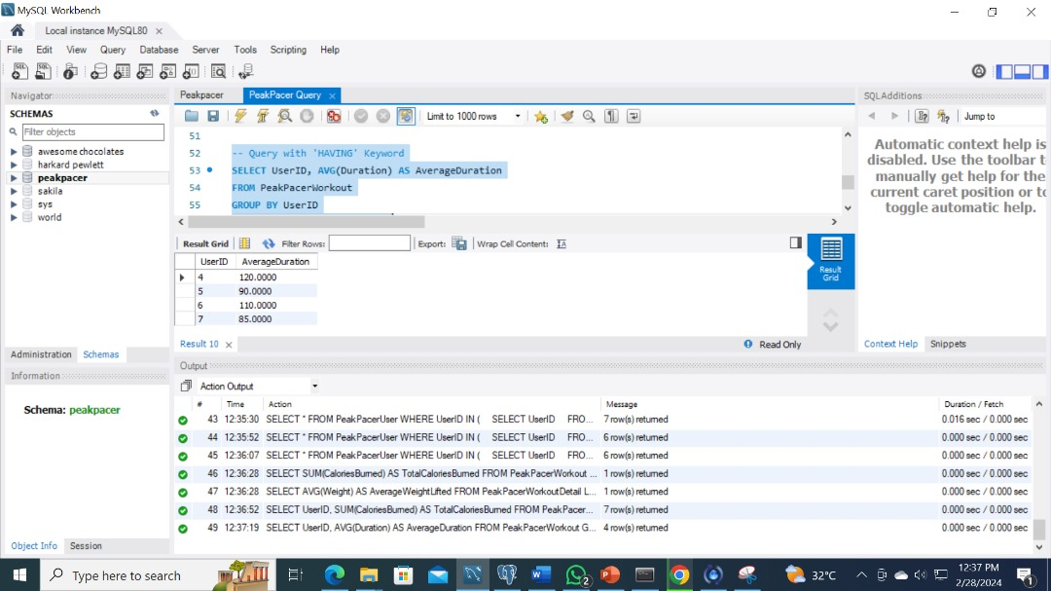

* Query with a LEFT or RIGHT join.

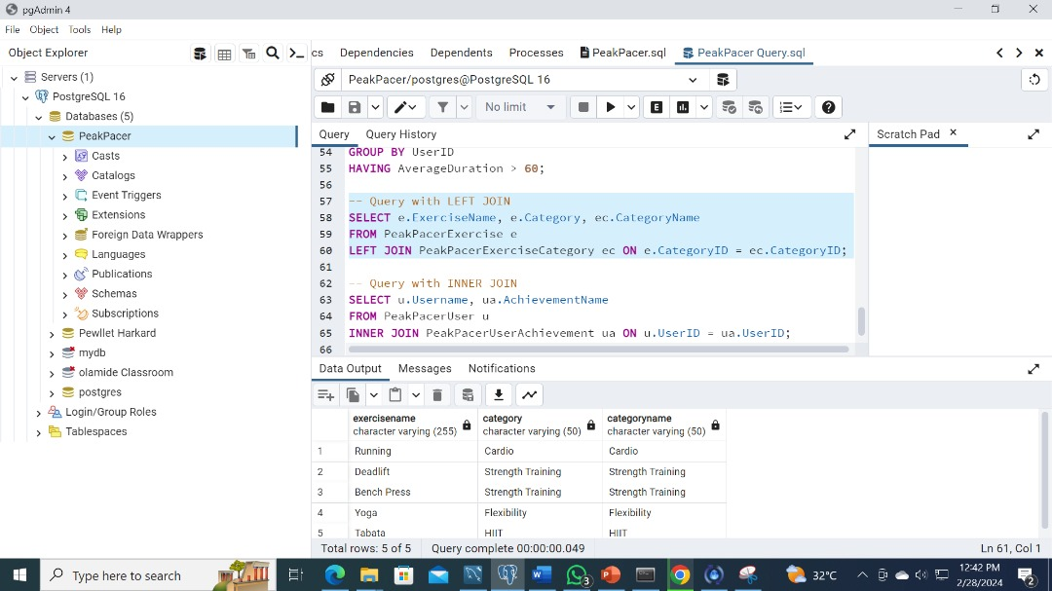

* Query with an INNER join

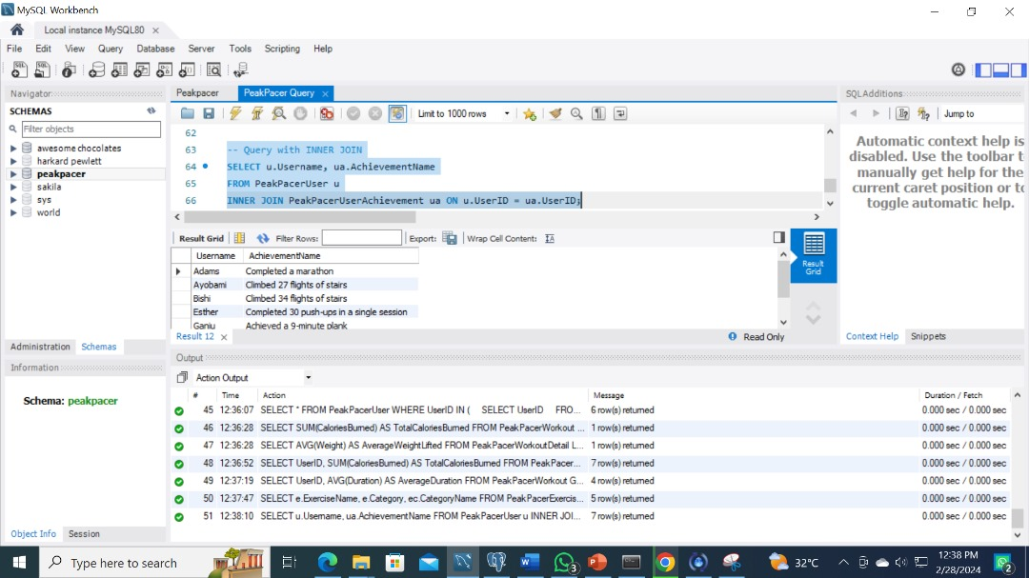 and

* 2 different queries should contain an aggregate function

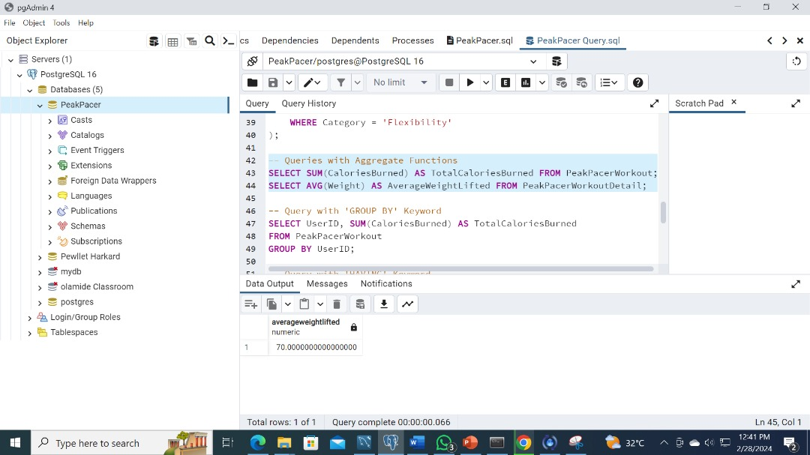

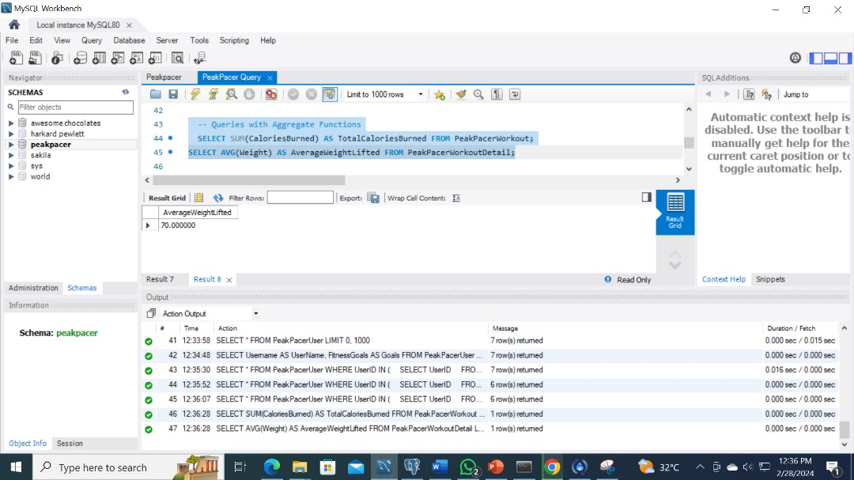

# CHALLENGES FACED

In the development process, when writing the codes we got to a stage where we needed a primary Key"Exercise Category" which was a necessary because the exercises to be taken includes different parts of the body and by categorizing exercises, users can easily navigate through their workout routines, whether they're focusing on cardio, strength training or flexibility.This classification allows users to set goals tailored to their desired outcomes, such as burning calories, building muscle, improving endurance, or mastering a particular skill.

How Was The Challenges Mitigated And Controlled.

This challenge made us go back to the database schema created. Then a new table was create with EXERCISECATEGORY as a primary key with “categoryname” and “CategoryID” in the other rows.

After that CategoryID is added as a foreign key to the table with EXERCISE as the primary key.Then we went back to the MYSQL workbench and re- run the test

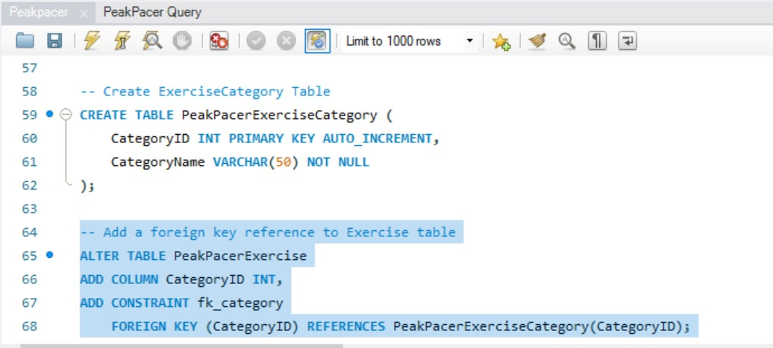

FUTURE ENHANCEMENTS FOR THE APP

1. Personalized Music Integration: Elevate the user experience by allowing seamless integration with personal playlists from various music apps. Empower users to exercise to their favorite tunes, enhancing motivation and enjoyment.
2. Interactive Virtual Assistant: Introduce an advanced virtual assistant or instructor with interactive features. Tailor encouragement and instructions based on user progress, creating a dynamic and engaging fitness environment.
3. Dynamic Aerobics and Dance Sets: Expand the application's appeal by incorporating diverse sets of aerobics exercises and dance routines. Make workouts not only effective but also enjoyable, catering to a broader audience with varying fitness preferences.
4. Visual Learning through Animated Demonstrations: Enhance user understanding and form by introducing animated demonstrations for each exercise. Visual cues ensure proper execution, reducing the risk of injuries and promoting effective workout sessions.

CONCLUSION

After all the queries , testing , and checking for the reliability of the application”**PEAKPACER”**. We wrote a summarized PowerPoint presentation.